(Note: I run on a MacBook Pro, 2020, M1 apple silicon chip, UTM is one of the few VM’s that run for the M1 and M2 chips.)

Log into CentOS 7 with the username “root” and the password you set for the root user. Once credentials are correct, you will get prompted [root@localhost ~]#

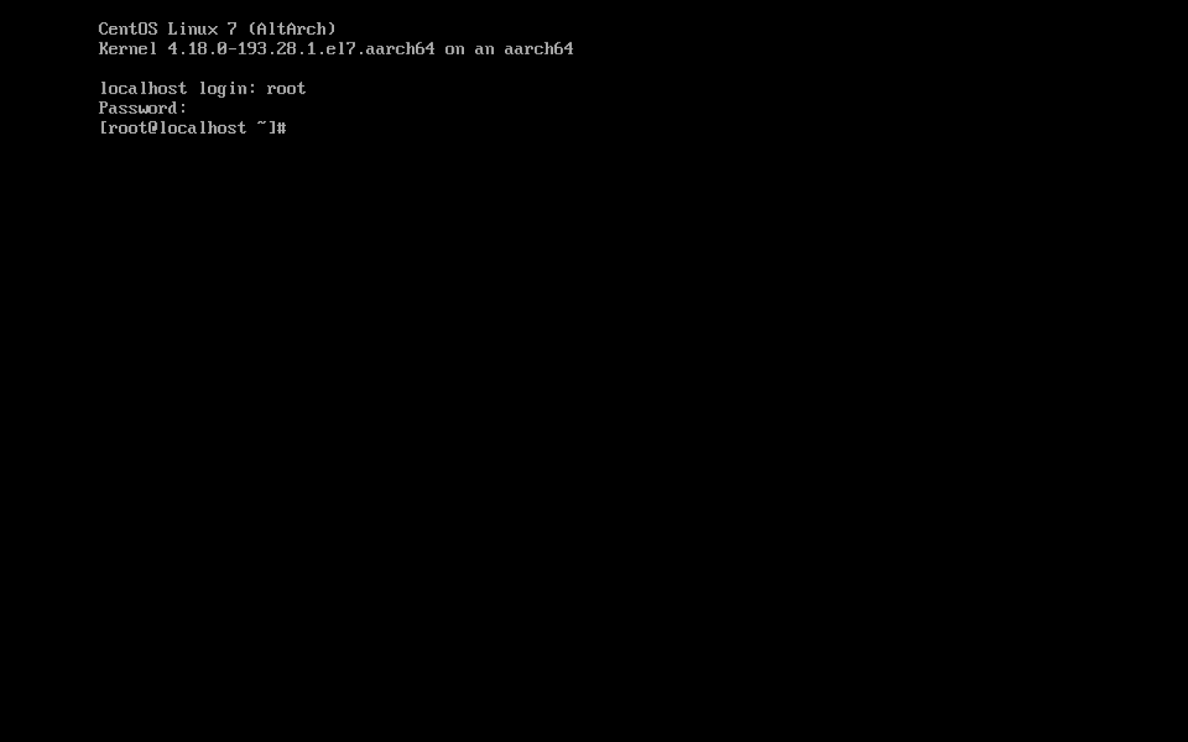

In the settings (while CentOS VM is powered off), click on “Network” > “shared network” or “NAT”

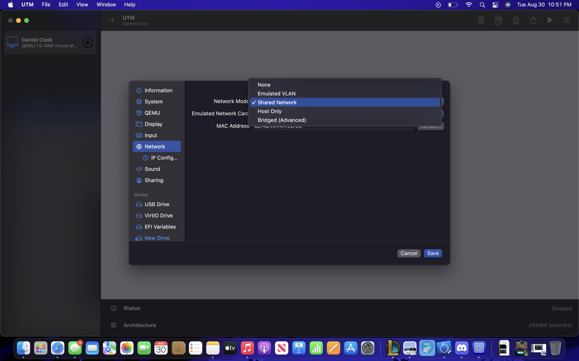

Change the value of “ONBOOT” from “no” to “yes” in the editing mode (“i”) and saved it by pressing ESC and saved it by typing “:wq” then rebooted the machine

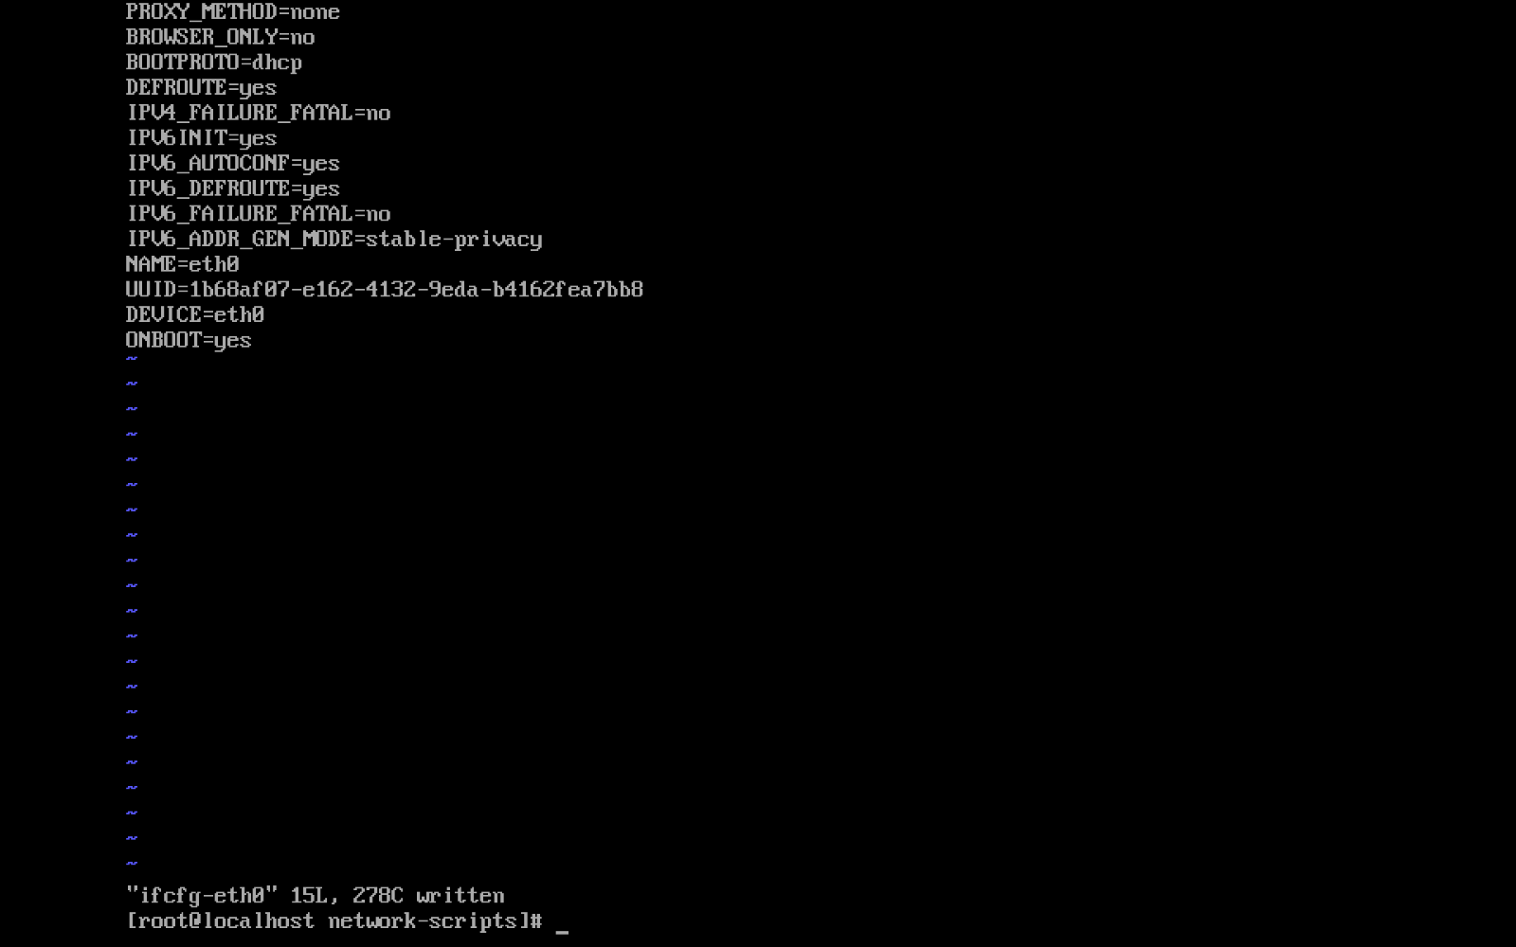

With the command “# ping www.google.com” you can test if the VM is connected to the internet successfully.

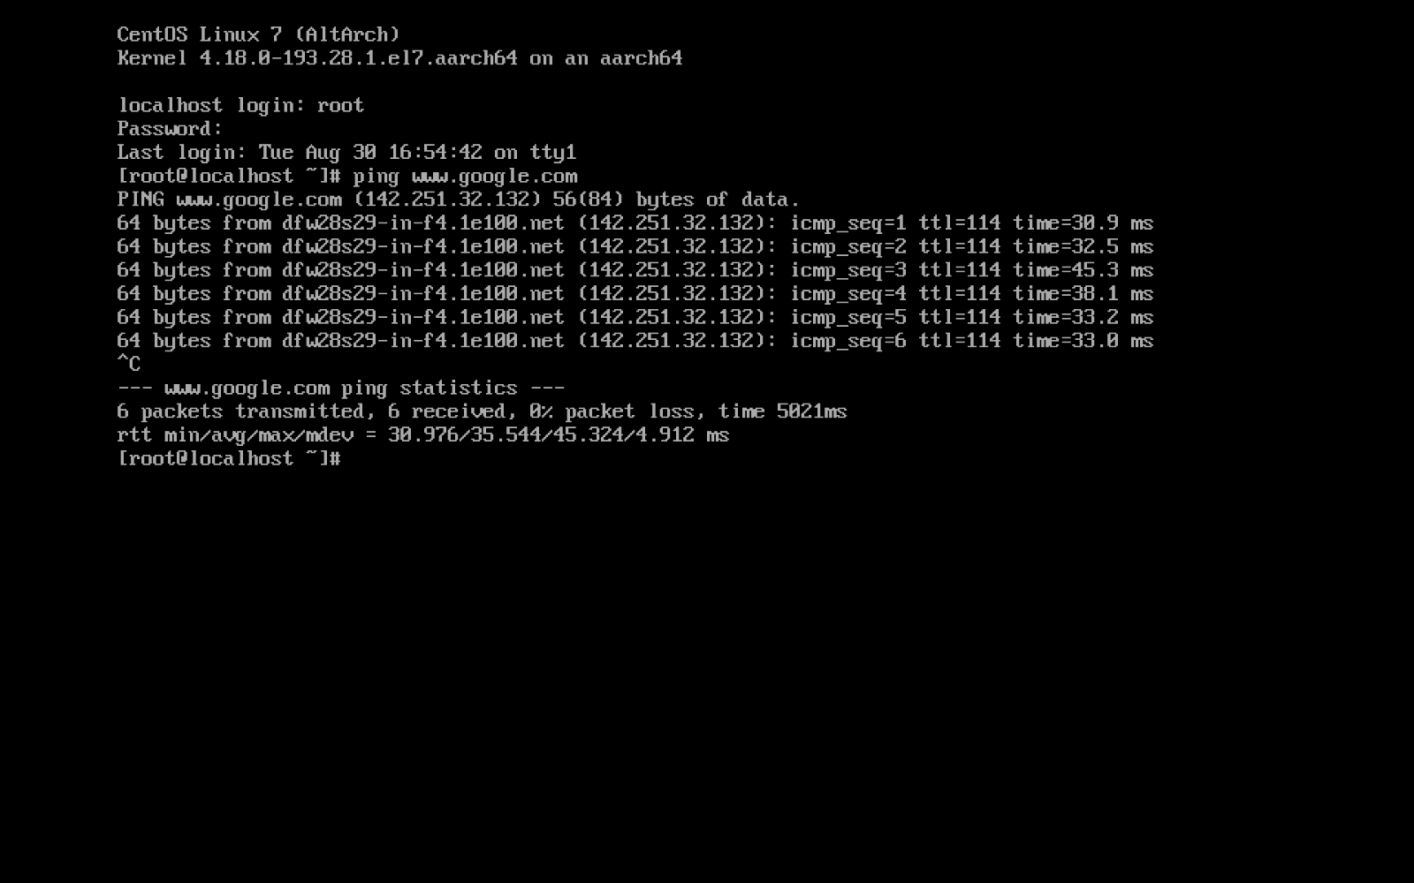

For UTM there is not really a snapshot button on the VM, but you can create a copy of the file of the VM. You can also clone the machine.

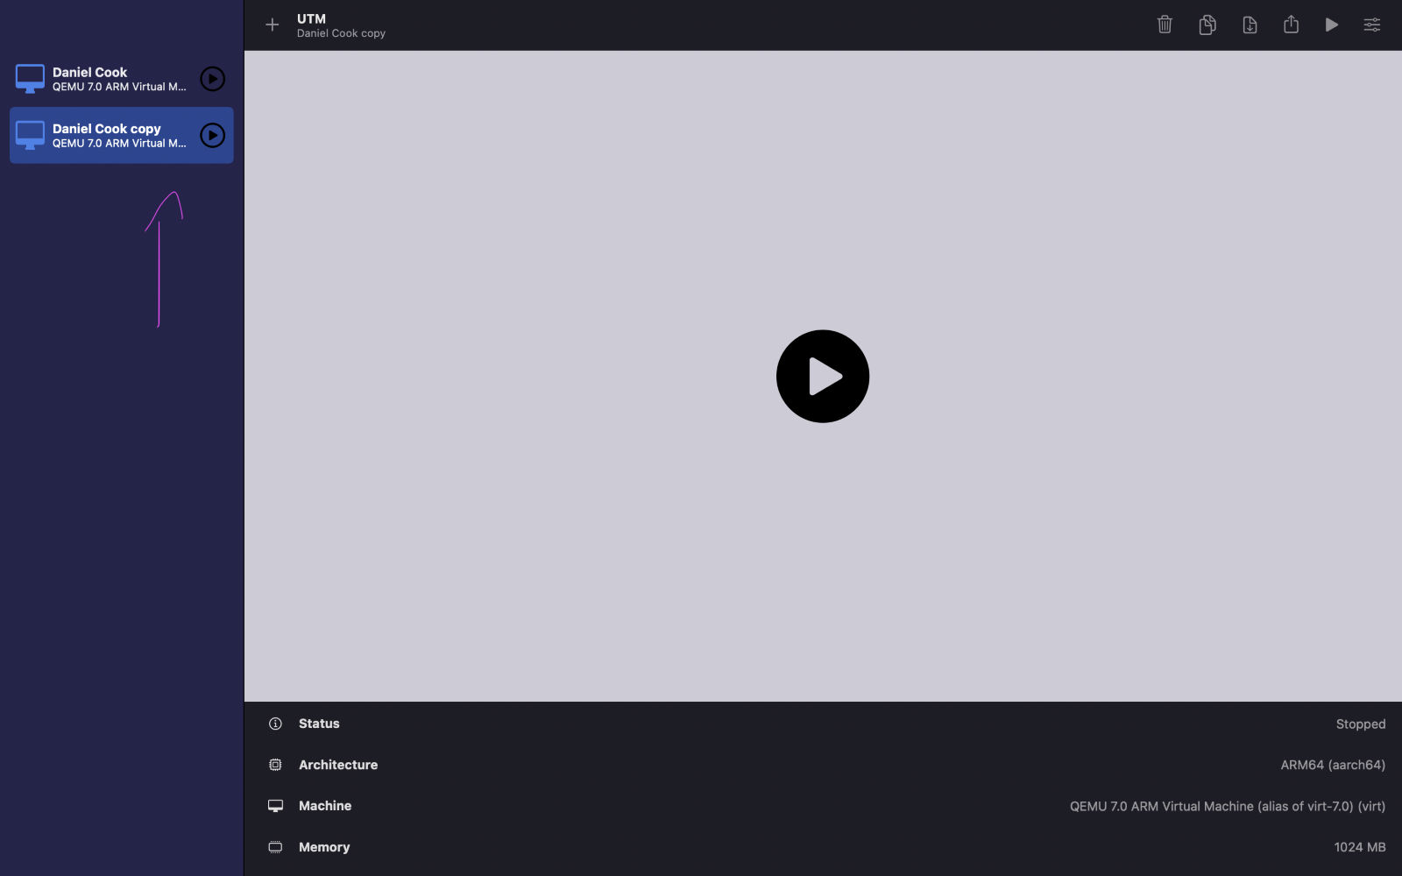V